Each port of WR switch uses a strict priority queue. The packets with hightest priority will go to this queue. E.g. Packets with Priority 7 will go to this queue. If the hightest priority within the switch nework is 6, the packets with priority 6 will go to this queue. All normal queue processing stops until this queue is empty.
When the strict priority queue is empty, other queues will be scheduled by the Weighted Round Robin (WRR) algorithm. Each priority has one queue. The WRR algorithm is as following：
Priority | Queue No | Bandwidth for queue
0 | 0 | x | x+2x+3x+4x+5x+6x+7x=1Gbps
1 | 1 | 2x | x+2x+3x+4x+5x+6x+7x=1Gbps
2 | 2 | 3x | x+2x+3x+4x+5x+6x+7x=1Gbps
3 | 3 | 4x | x+2x+3x+4x+5x+6x+7x=1Gbps
4 | 4 | 5x | x+2x+3x+4x+5x+6x+7x=1Gbps
5 | 5 | 6x | x+2x+3x+4x+5x+6x+7x=1Gbps
6 | 6 | 7x | x+2x+3x+4x+5x+6x+7x=1Gbps
7 | Strict priority queue | 1 layer 500Mbps = 45 us ± 42 us
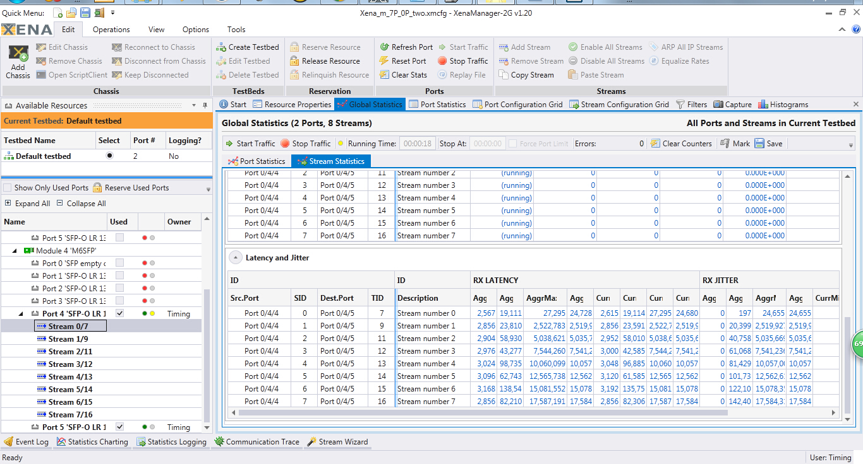
The test packet is with 1248 bytes length.
Priority
Strict priority queue
WRR

7
6
5
4
3
2
1
0
100Mbps
100Mbps
100Mbps
100Mbps
100Mbps
100Mbps
100Mbps
100Mbps

Simple Test

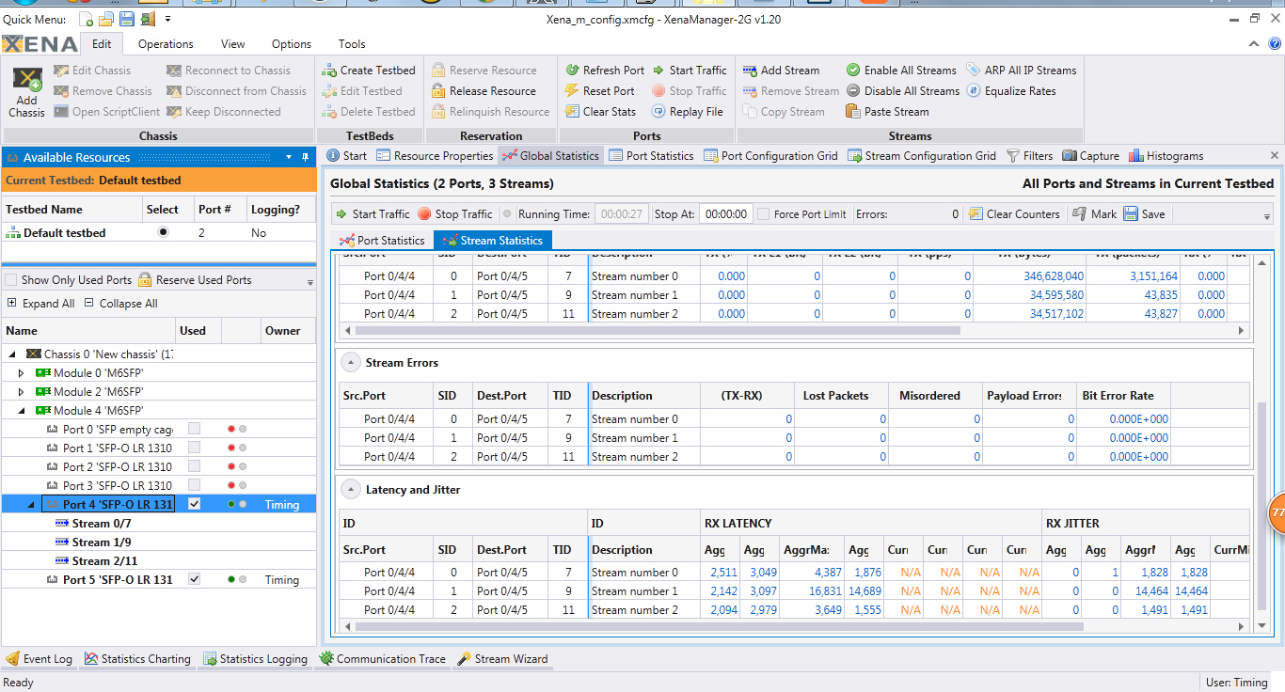
Priority

7
6
5
100Mbps 110bytes Burst 11 packets/100us
10Mbps random
10Mbps random

